Task 1.
I would like to suggest an improvement for the Request and Exception (Derogation) module.

When a request ticket is opened, especially for a school fee extension or payment derogation, the system should automatically send an SMS and/or WhatsApp notification to the responsible users so that the request can be reviewed promptly.

In addition, when the staff member opens the student's request file, the system should provide a complete student overview to support better decision-making.

For example:

-Student full name
-Class and section
-Total school fees
-Amount already paid
-Outstanding balance
-Previous payment history
-Discipline status
-Attendance summary
-Previous derogations or requests
-Academic performance (optional)
-Parent contact information

This information will help the reviewer quickly understand the student's situation and make a more informed decision regarding the request.

The objective is to transform the request ticket into a decision-support tool rather than just a simple approval workflow.

Task2
Another important improvement for the Request and Derogation module is parent communication.

When a ticket is submitted, the parent should immediately receive an SMS and/or WhatsApp notification containing:

-Ticket number
-Student name
-Request type
-Expected response time

Example:

"Dear Parent, your request for student $StudentName has been successfully registered.

Ticket No: #$TicketNumber
Request Type: Fee Payment Extension

The school will review your request and provide a response within 24 hours.

Thank you."

This will reassure parents that their request has been received and is being processed.

Additionally, the system should notify the parent whenever the ticket status changes (Under Review, Approved, Rejected, Additional Information Required, etc.).

Subtask 2.1
This sms will consume more SMS
“🎫 TICKET UPDATE
Ticket: DGR-AHSOI
Student: Room
Type: Dérogation (prolongation des frais)
Status: Approuvé

Admin Note: Nous comptons sur votre collaboration
Thank you, Complexe Scolaire Integrale.”

Task 3
Update the labels. Here is a screenshot where labels are highlighted the and showing the expecting text with red color don’t update the design by misunderstanding. You only need to update label text as mentioned in red color.

Sub task 3.1
In Request & Applications table must add the two columns Parents and Class with section as mentioned by drawing the line on table to understand what I want.
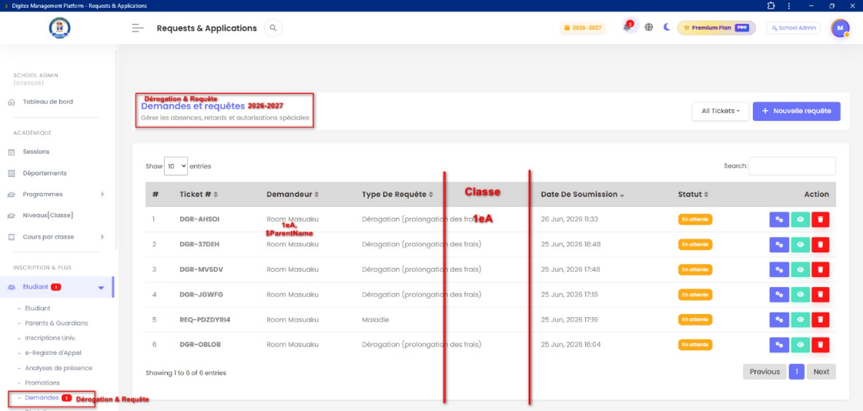

Task 4
I would like to enhance the Fee Extension / Derogation workflow.

Once a derogation request is approved, the system should continue monitoring whether the parent has honored the commitment or not.

Suggested statuses:

-Submitted
-Under Review
-Approved
-Honored
-Expired
-Rejected

When a derogation is approved, the school defines a new payment deadline.

The system should automatically send reminder notifications:

1.Before the deadline (e.g. 1 day before)
2.On the deadline date
3.After the deadline if payment has not been made

Example:

"Dear Parent, this is a reminder that your approved fee extension for student $StudentName will expire on $DueDate. Please complete the payment before the deadline."

If the payment is still not made after the deadline:

"Dear Parent, your approved fee extension for student $StudentName has expired. According to school policy, the student may no longer be allowed to attend classes until the outstanding balance is settled."

The system should automatically mark the request as Honored if the required payment is received before the deadline, or Expired if the deadline passes without payment.

This will allow schools to track not only approved requests but also compliance with approved commitments.

Task 5
I would like teachers to be able to log in using either their staff ID code or their own phone number, as I mentioned from the beginning.
In our school environment, email addresses are not commonly used by teachers. Most teachers are more comfortable using their phone numbers.
For this reason, I believe the following options should be supported:
Teacher ID Code or Registered Phone Number
This approach is more practical and better aligned with our local reality.
It will also encourage teachers to use the WhatsApp chatbot more frequently, since the ID code is simple, easy to remember, and already part of the school's daily operations.
The objective is to make access as easy as possible while maintaining security through OTP verification.

Task 6
Look at staff management status dropdown it must be localized use the language key here.
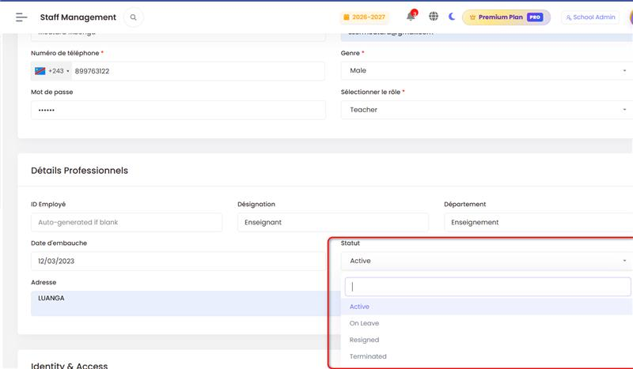
Fund requests dashboard cards are also hardcoded English please update these card with lang keys
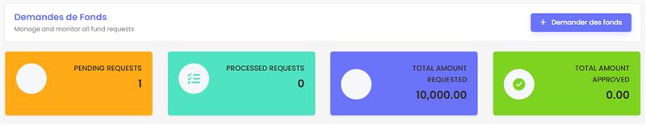

Task 7
Please provide support for additional dynamic variables in SMS, WhatsApp, and Email notification templates.
The goal is to allow administrators to create more personalized and contextual messages using different placeholders.

Task 8
For budget expenditure tracking, please provide the ability to assign multiple recipients to budget notifications.

In many schools, a budget line may be monitored by more than one person.

For example:

-School Accountant
-Principal
-Finance Officer
-Head Office Finance Team

Whenever an expense is recorded against a budget line, the notification should be sent to all assigned recipients, not just one person.

Example:

Budget Line: Fuel Purchase
Expense Recorded: USD 130
Remaining Budget: USD 700

The notification should automatically be delivered to Person 1, Person 2, Person 3, etc., according to the configured recipients.

This will improve transparency, accountability, and real-time budget monitoring.

Task 9
For security and accountability purposes, every fund disbursement approval should require password confirmation from the responsible person.

Before approving or releasing funds, the system should prompt the authorized user to re-enter their password.

Example:

1.User clicks "Approve Fund Request"
2.System displays a password confirmation dialog
3.User enters their password
4.System validates the password
5.Approval is completed and logged

This additional verification layer will help prevent accidental approvals, unauthorized transactions, and strengthen financial control.

It will also improve auditability by confirming that the approval was intentionally performed by the responsible person.

Task 10
Please provide the ability to edit and update email notification templates directly from the system configuration settings.
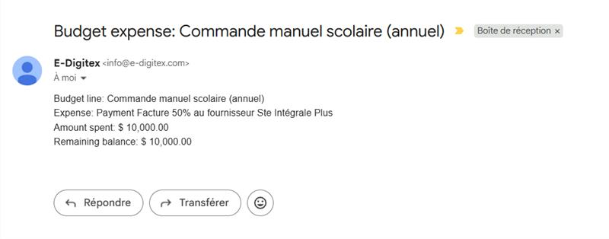

Task 11

System is sending the most of the notification using sms. I cant see this notification from whatsapp email, or bells icon.

Task 12

Please provide the ability for the system to notify an agent automatically once their payment has been processed.

For example:

"Dear $AgentName, your payment of $Amount for $Period has been successfully processed. Thank you."

The system should also clearly show:

-Paid agents
-Unpaid agents
-Payment period
-Total amount paid
-Total amount unpaid
-Yearly payment summary

This will help the administration track agent payments by period and by year, while keeping each agent informed automatically.

Task 13
Month in Date should also be in French if user selected language is French. especially on invoices, reports, results etc.

Task 14
Please also consider SMS, WhatsApp, Telegram, and Email notifications for school events and invitations.

Schools organize many activities throughout the academic year, such as: Report card signing, Parent meetings, School celebrations Academic events, Religious activities, Sports competitions, Examination reminders, Graduation ceremonies, Orientation sessions

These notifications should be highly personalized using dynamic variables.

For example:
"Dear Parent, you are invited to attend the report card signing ceremony for your child $StudentName from Class, $ClassName on, $EventDate at, $EventTime."

Therefore, the event notification module should support variables such as:

Parent Name, Student Name, Student ID, Class, Section/Option, School Name, Event Name, Event Description, Event Date, Event Time, Venue, Contact Person, Ticket Number (if applicable)

This will allow schools to communicate professionally and effectively with parents, students, teachers, and staff.

